
Louisiana
Office of the Governor
Auctioneers Licensing Board

11736 Newcastle Avenue, Bldg. 2, Suite C
Baton Rouge, LA 70816
Telephone 225.295.8420 Fax 225.372.8584
Website: www.lalb.org Email: admin@lalb.org

MINUTES FROM A REGULAR BOARD MEETING

Date: Tuesday, January 12, 2016 Time: 11:00 am
Place: Louisiana Municipal Association, 700 North 10th Street, Baton Rouge, LA 70802

- CALL TO ORDER- T. Steinkamp ROLL CALL- S. Edmonds
Board Members present: Tessa Steinkamp- Chair, James Sims-Vice-Chair, Jeff Henderson, and Charles ‘Clayton’ Brister Absent: Darlene Jacobs- Secretary/Treasurer
Others: Sandy Edmonds, Anna Dow, Larry Bankston
A quorum was declared.

MOTION AND SECOND to amend the agenda to add reinstatement applications for Lonnie Nixon and Nixon Auctioneers: J. Sims, C. Brister. Roll Call Vote: C. Brister-yes, J. Henderson-yes, J. Sims-yes, T. Steinkamp-yes. MOTION PASSED UNANIMOUSLY.

- PUBLIC COMMENT on today’s agenda items (5 minutes per person)

- APPROVAL OF MINUTES from November 10, 2015
MOTION AND SECOND to approve the minutes from November 10, 2015: J. Sims, J. Henderson. MOTION PASSED UNANIMOUSLY.

- BUSINESS

1. Attorney Report/Investigative Report- A. Dow, L. Bankston
This may be handled in executive session Pursuant to LA RS 42:17 A (1), LA RS 42:17 A (4), and/or LA RS 42:17 A (10)

MOTION AND SECOND to enter into executive session for attorney/investigative report pursuant to LA RS 42:17 A(1), A(4) and/or A(10): J. Sims, C. Brister. Roll Call Vote: C. Brister-yes, J. Henderson-yes, J. Sims-yes, T. Steinkamp-yes. MOTION PASSED UNANIMOUSLY.

MOTION to exit Executive Session: J. Sims, C. Brister. Roll Call Vote: C. Brister- yes, J. Henderson- yes, J. Sims- yes, T. Steinkamp- yes. MOTION PASSED UNANIMOUSLY.

2. Request from Robert Burns to address the Board to expand public comment time

3. Review of Tested Auctioneer Applicants:
1. Bradley Hamilton
2. John Calhoun
3. Jay Williamson (completed apprenticeship)
MOTION AND SECOND to approve Bradley Hamilton, John Calhoun, and Jay Williamson as auctioneers: J. Sims, C. Brister. MOTION PASSED UNANIMOUSLY.

4. Review of Reciprocal Auctioneer Applicants:
1. Lynn Lee (temp license issued 1/1/16)
MOTION AND SECOND to approve Lynn Lee as auctioneer: J. Sims, J. Henderson. MOTION PASSED UNANIMOUSLY.

2. David Myrick (temp license issued 1/1/16)
MOTION AND SECOND to approve David Myrick as auctioneer: J. Sims, C. Brister. MOTION PASSED UNANIMOUSLY.

3. Elliot Paul (fax)
MOTION AND SECOND to approve Elliot Paul as auctioneer pending receipt of all original documents within 15 days: J. Henderson, C. Brister. MOTION PASSED UNANIMOUSLY.

5. Review of Auction Business Applicants:
1. Tradition Auction Services (temp license issued 1/1/16)
2. RealtyBid International, LLC
MOTION AND SECOND to approve Tradition Auction Services and Realty Bid International as Auction Businesses: J. Henderson, C. Brister. MOTION PASSED UNANIMOUSLY.

3. Crescent City Auction Gallery
4. Elliot Paul & Co.
MOTION AND SECOND to approve Crescent City Auction Gallery and Elliot Paul & Co. as Auction Businesses pending receipt of all original documents within 15 days: C. Brister, J. Henderson. MOTION PASSED UNANIMOUSLY.

6. Review reinstatement applications:
1. Lonnie Nixon
2. Lonnie Nixon Auctioneers
MOTION AND SECOND to approve Lonnie Nixon as auctioneer and Lonnie Nixon Auctioneers as Auction Business pending receipt of all original documents within 15 days: J. Sims, J. Henderson. MOTION PASSED UNANIMOUSLY.

7. Review of Auctioneer School provider renewals:
1. Burk Baker
2. Continental Auctioneers School
3. Mendenhall School of Auctioneering
4. Nashville Auction School
5. North Georgia School of Auctioneering
6. Reppert School of Auctioneering
7. Texas Auction Academy
8. Troy University Dothan Campus
9. World Wide College of Auctioneering
MOTION AND SECOND to approve Auctioneer School providers as listed: J. Sims, C. Brister. MOTION PASSED UNANIMOUSLY.

8. Continuing Education statute revision
MOTION AND SECOND to approve discretionary version of statute: J. Sims, C. Brister. MOTION PASSED UNANIMOUSLY.

9. Approval of financials
MOTION AND SECOND to approve financials: C. Brister, J. Sims. MOTION PASSED UNANIMOUSLY.

- NEXT MEETING DATE – March 8, 2016

VII. Adjourn
MOTION AND SECOND to adjourn: J. Sims, J. Henderson. MOTION PASSED UNANIMOUSLY.

Pending Litigation

Robert Burns vs. Dow
Docket # 603248

Submitted by: Sandy Edmonds, Executive Assistant

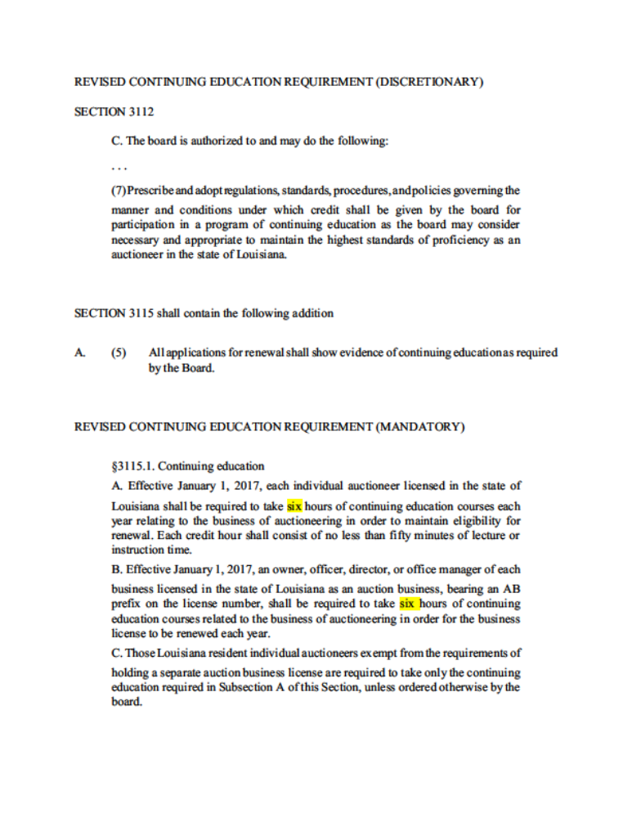

SECTION 3112.
B. The board is authorized to and shall do the following:
. . .
(2) Prescribe and adopt regulations, standards, procedures, and policies governing the
manner and conditions under which credit shall be given by the board for
participation in a program of continuing education as the board may consider
necessary and appropriate to maintain the highest standards of proficiency as an
auctioneer in the state of Louisiana.

